Inclusion and Disability

I've put together a collection of books by Indian writers that talk about diversity and being inclusive. These books are meant for children aged 5 to 13 years. They encourage young readers to embrace and respect differences, like skin colour, gender, backgrounds, and abilities. These books are beautifully illustrated and written in a way that's easy for kids to understand, helping them feel good about being unique.
-Saina Munjal

Book 1
When Adil Speaks Words Dance – Lavanya Karthik
Topic: Inclusivity, disability
Age recommended: 5-7 years
Publisher: Duckbill, November 2020
Why it’s important: This tale of empathy, inclusivity and friendship is a beautiful and important story into how kids can be more sensitised to people from different backgrounds. Sometimes kids with special needs, such as Adil, may be left out by other kids their age, this may not be on purpose but it may be because children don't know how to communicate as they can’t do it through words. This book shows an alternative and shows how Adil is also made to feel included and loved.

Summary: Adil, a young deaf boy, speaks in a different language than his peers. He speaks with hands, but not everyone can understand his language. A fellow classmate wants to be friends with Adil, and now finds a new way to communicate, through art.

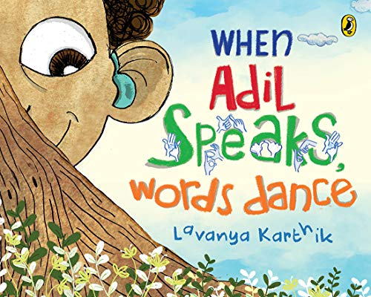

Book 2
Different Differenter – Jyoti Gupta
Topic: Racism, understanding ourselves
Age recommended: 6-8 years
Publisher: Colourism Project, February 2019
Why it’s important: In India, most of us have been conditioned to think that lighter skin is considered more beautiful, however there are many kids who would have darker skin and wouldn't understand why they are different. This activity book goes into the explanation about why each of us have different skin tones, backgrounds, and families, along with having many interactive activities to make children feel more comfortable in their own skin. The book helps explain scientific explanations to our genetic makeup but in a fun and easy way to enable kids to feel confident in their differences.

Summary: The book contains activities and explanations under the topics: “Seeing difference, understanding difference, learning difference, loving difference.”

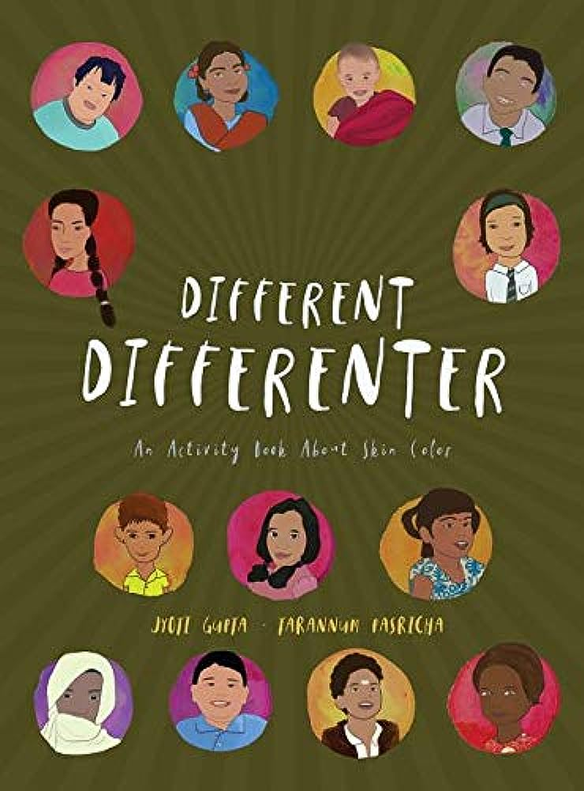

Book 3
Wings To Fly – Sowmya Rajendran
Topic: woman in sports, inclusion, disability
Age recommended: 6-8 years
Publisher: Tulika Publishers, January 2006
Why it’s important: This empowering book tackles 2 very important issues of women in sports, and sports for disabled. The book shows how a young girl didn’t let her disability bring her down, yet found her interest in sports and pursued it, regardless of her gender. The book an help give young kids a glimpse of hope to show that through hard work and determination, anything you set your mind to, is possible.

Summary: “Wings To Fly” is a true story of an athlete, Malathi Holla. Malathi lost strength in her legs when she was just a baby, despite this, she fought through and became a world class athlete, along with a charismatic banker. Malathi fights for the issues of change for women in sports and comes out on top!

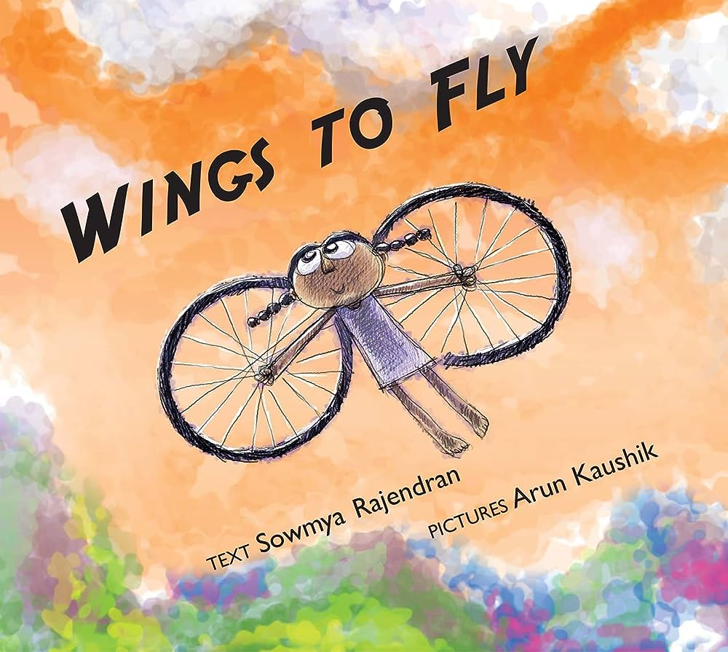

Book 4
Neel on Wheels – Lavanya Karthik
Topic: disability empowerment
Age recommended: 5-7 years
Publisher: Duckbill Books, October 2012
Why it’s important: Very often, wheelchairs are seen as a disability, or as something that is a setback, however this book shows how the innocent young boy believes that his brothers wheelchair has powers. By making the protagonist appear powerful, it tries to show the young readers that disabilities are normal and not something to be afraid of.

Summary: Offering a different perspective, this book shows the unique abilities that Neel and his wheelchair have. It shows how a young boy’s imagination runs wild, making him believe that only his big brother can save him from the dangers of the world. No matter what the danger, there’s no need to be scared, as big brother Neel has wheels to protect his little brother from any harm.

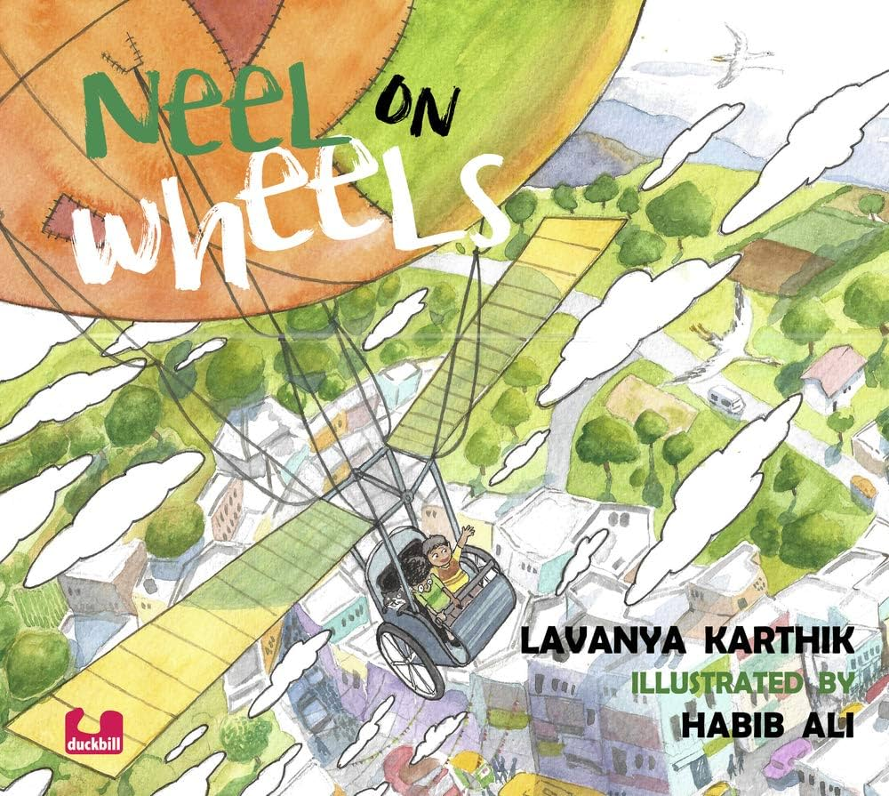

Book 5
Why Are You Afraid To Hold My Hand? – Sheila Dhir
Topic: Disability, inclusion
Age recommended: 7-13 years
Publisher: Tulika Publishers, January 2005
Why it’s important: This is an an eye-opening book about people’s attitudes, giving an alternative view point. We are always told to help those who we feel “need it”, however this book shows the fact that even children with disabilities just want to feel normal. It’s important for kids to read this book to know what not to say or do. There are many things’ kids say without a malicious intent, however it may be hurtful to children with disabilities. It shows the importance of inclusion, and to respect, not pity, the child.

Summary: “Yes I have a problem, no it won’t go away, take me for who I am, just a child who wants to play.” The book features a child with cerebral palsy, and it's like a conversation this child has with society without using words. It talks about how people react, the questions they ask, and the misunderstandings, doubts, fears, and ideas they have. The child answers in simple and heartfelt verses.

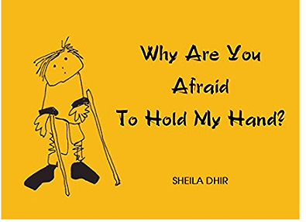

Book 6
Manya learns to roar – Shruti Rao
Topic: disability, inclusion
Age recommended: 7-12 years
Publishers: Duckbill Books, August 2017
Why it’s important:
This book provides representation for children who stammer and feel unseen and misunderstood, reducing any stigma or isolation they may feel. It educates both children and adults about the challenges they face and aims to inspire others who may be in the same boat and encourages empathy.

Summary: "Manya Learns to Roar" is a tale about a girl named Manya who faces challenges because she stammers. The story shows how she overcomes her worries and doubts in a realistic and enjoyable way. Manya, a student in class 5B, is thrilled to take part in the Panorama fest, an event where schools compete against each other.

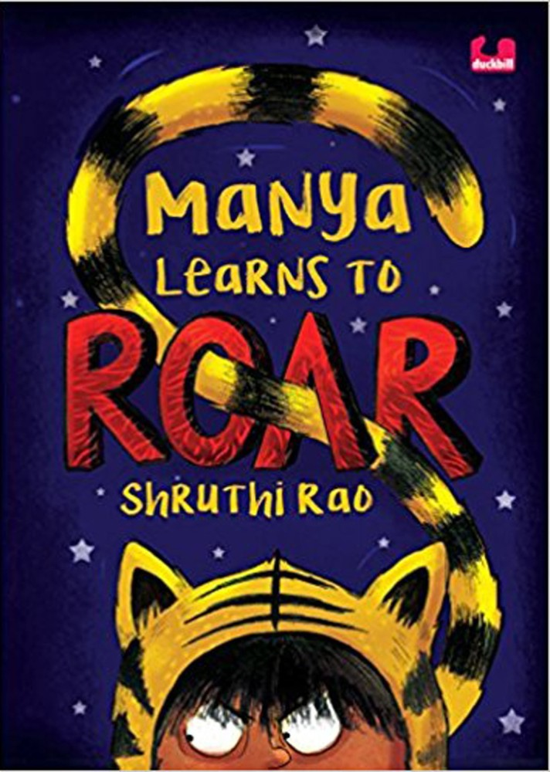

Book 7
Flute In The Forest - Leela Gour Broomie
Topic: disability, inclusion
Age recommended: 9-13 years
Publisher: Puffin Books India, January 2010
Why it’s important: "Flute in the Forest" is a heart warming tale inspired by the author's real-life experiences. Leela has polio and yet her adventurous spirit leads her through many fun and thrilling experiences. This book shows how a young girl didn’t let her illness get her down, rather she took charge of her own life and continued to do what she loves.

Summary: Thirteen-year-old Atiya, despite her physical disability, explores the jungle near her forest officer father's home. She becomes enchanted by a mysterious flute's music and decides to learn how to play it, even against her father's wishes. Her music lessons bring her closer to Ogre Uncle and his Kurumba tribal daughter, Mishora. Atiya's musical talent transforms her father's perspective and brings harmony to various relationships in the story.

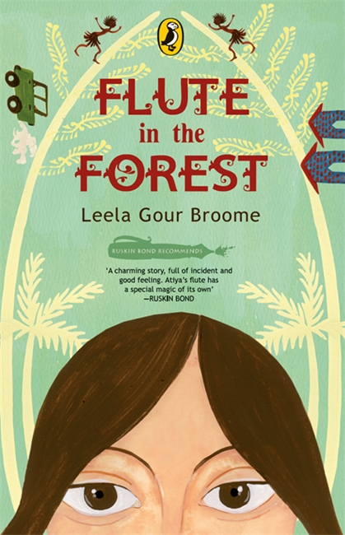

Book 8
Against All Odds – Ramendra Kumar
Topic: disability, inclusion
Age recommended: 8-11 years
Publisher: Duckbill Books and Publications Private Limited, September 2017
Why it’s important: This book is important because it addresses the issue of discrimination against individuals with disabilities, specifically in the context of sports. It highlights the importance of inclusion and showcases that abilities are not limited by physical differences. By portraying Karthik's triumph and acceptance, this story encourages a more empathetic society.

Summary: Karthik is a young boy who loves to play football, but he is discriminated against at his new school when the coach doesn’t let him play due to his missing arm. In the end Karthik scores the winning goal, being celebrated by everyone despite his disability. A heart-warming story that will help reduce the stigma against disabilities.

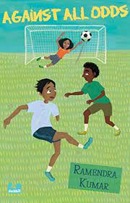

Book 9
A Walk With Thambi – Lavanya Karthik
Topic: disability, perseverance
Age recommended: 5-8 years
Publisher: Tullika Books, January, 2017
Why it’s important: Through sensory descriptions, this book highlights the world through Thambi, a blind boy’s, perspective. It is important for kids to be able to put themselves in the others position to help understand them and support them, this book helps with that.

Summary: The book shows us a fun adventure in the life of a blind boy from his guide dog's perspective. When they leave home, the mom tells them not to do things like running on the street, playing in the river, climbing trees, or getting dirty. But, of course, both the little boy and the dog can't resist the excitement of these activities. We get to experience how Thambi enjoys his day using his senses – feeling the wind, hearing the noisy street, and smelling all the different scents at the market. We also see him having a great time by jumping into the river, hanging from a tree, and playing with his friends, who don't even notice his disability.

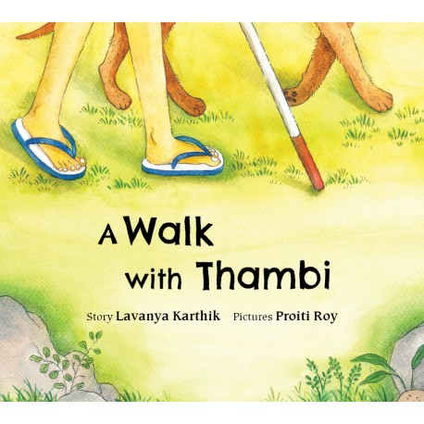

Book 10
Kanna Panna – Zai Whitaker
Topic: disability, special ability
Age recommended: 5-9 years
Publisher: Tulika Publisher, January 2015
Why it’s important: Little Kanna cannot see, but that turns out to be his biggest strength when he gets everyone out of a trap-ped cage. Turns out his disability was actually his super power.

Summary: Kanna has lots of fun words in his mind, but he usually doesn't talk much. One day, he's in dark caves with his aunt's family, and the lights go out. They're scared and don't know how to get out. But Kanna isn't scared because he can't see even with light. Surprisingly, he guides them confidently and starts talking a lot, revealing the chatty and confident side of his personality.

