Reading List on
Body Positivity and Awareness

I've compiled a collection of children's books that enable adolescents to enhance body positivity, self-awareness, and understanding of their own feelings. In today's world, we often turn to the internet for answers, but the accuracy of the information can be uncertain. Moreover, we're constantly exposed to images that can erode our self-confidence. If we don't fit the ideal portrayed in these images, we may start feeling inadequate. Books addressing these sensitive topics are quite rare, especially in South East Asia and particularly for young children. All these books have been written by authors from the Indian subcontinent and in English. Some have been translated into other Indian languages as well.
-Saina Munjal

Book 1
Small or Tall, We Sparkle After All – Aditi Wardhan Singh
Topic: Body Positivity
Age recommended: 4-6 years
Publisher: Raising World Children LLC, November 2020
Why it’s important: This charming book tells the story of a young girl named Shreya who struggles with her small stature. It aims to boost children’s self-confidence by combining straightforward explanations of biology with intriguing references to Hindu mythology. The book’s primary focus is on promoting body positivity and taking a stand against bullying. It encourages young readers to embrace their true selves and emphasizes that kindness holds greater significance than physical appearance.

Summary: Shreya, a young girl unhappy with her small stature, wishes to grow taller on her birthday. Disappointed that her wish doesn’t come true, her mother comforts her by sharing Hindu mythology stories about small creatures and explaining the biological reasons for different sizes. Shreya’s brother highlights the benefits of being small, emphasizing that size doesn’t define a person’s worth.
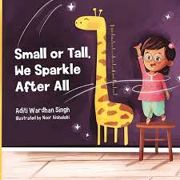

Book 2
Your Body is Yours – Yamini Vijayan
Topic: Body Awareness
Age recommended: 6-9 years
Publisher: Pratham Books, February 2021
Why its important: The book introduces the concept of cultivating a positive body image and promotes body positivity while discussing consent. Additionally, by using the correct names for body parts, the book intends to convey that discussing these topics openly is normal and healthy, encouraging children not to feel ashamed when addressing any part of their bodies.
From a very early age, girls are often instructed to be obedient. Vijayan has made an effort to instruct the children that they have the right to say no to anyone, whether it's a family member or someone else, if they feel their boundaries are being disregarded.

Summary: This illustrative book, written in straightforward language, empowers children to become acquainted with their body parts and teaches them the importance of saying "No" if they ever feel uncomfortable with physical contact. Using a series of questions and answers, it helps clarify the concepts of appropriate and inappropriate touch.

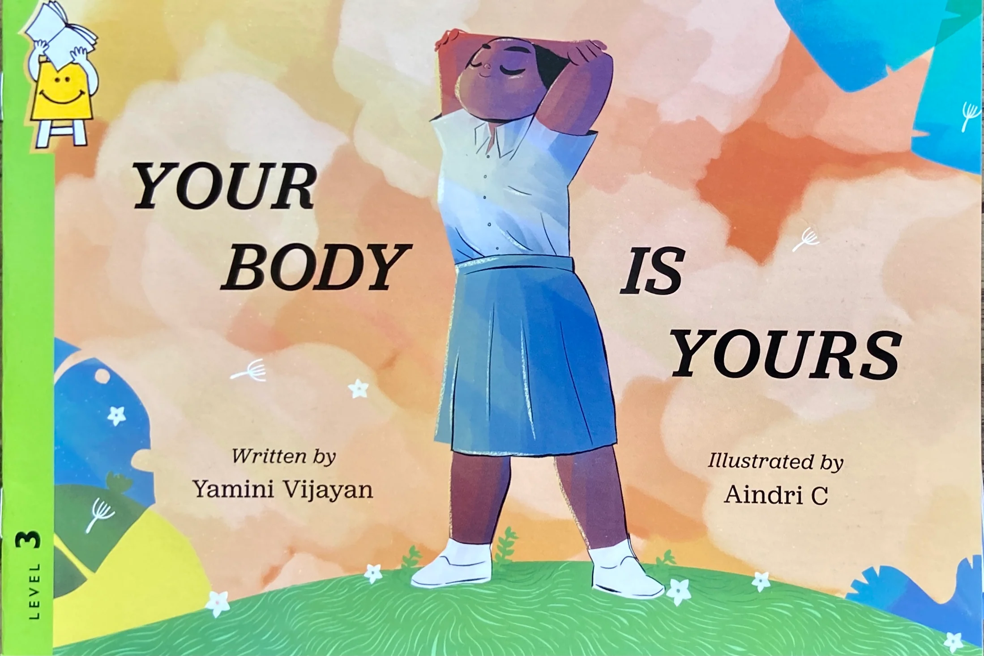

Book 3
Gulu- The essential guide to growing up for boys- Aditi Gupta, Tuhin Paul
Topic: Body Awareness, sexuality
Age recommended: 11-14 years
Publisher: Menstrupedia, May 2021
Why its important: Pre-adolescents go through a range of bodily and emotional changes that they don’t know how to address. In our Indian society we rarely address this important phase and its challenges. This comic book adresses sensitive topics around body changes, emotions, consent and bullying in great detail providing children a safe source of knowledge.

Summary: This comic book revolves around the life of a young boy named Gulu. It follows his daily routine and portrays his family addressing his inquiries while sensitively educating him about the physical and emotional changes that adolescents experience due to changing hormones. The book underscores the significance of a healthy diet, exercise, hygiene, physical attraction, reproductive changes, masturbation and self-care practices. It concludes with Gulu's parents discussing the topic of bullying, its various forms, and the importance of avoiding addictions.

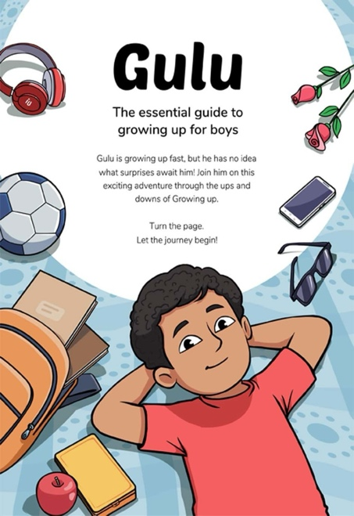

Book 4
Body Talk – Anjali Wason
Topic: Sex education
Age Recommended: 13-16 years
Publisher: Harper, May 2010
Why it’s important: This informative guidebook provides detailed responses to the awkward questions frequently posed by teenagers. It covers a wide range of sensitive topics that are often seen as taboo, and it even includes contact information for resources available in India for those seeking help related to sexual education.

Summary: This book functions as an extensive handbook, offering guidance to girls who may feel hesitant about asking certain questions. It incorporates narratives, quizzes, and expert input from medical practitioners. It begins with fundamental inquiries, like acne and eating disorders, and progressively explores more intricate topics such as sexual harassment, sexual orientation, STDs, protection, relationships, sex, menstruation, orgasm, and masturbation.

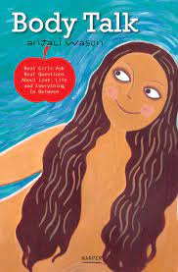

Book 5
The Curious Case of Mohit and Rumi the Rabbit – Varsha Varghese
Topic: Body positivity
Age Recommended: 12+ years
Publisher: The Irrelevant Project, January, 2017
Why it’s important: In a society that sets strict standards for how our bodies should look, this tale revolves around Mohit, an eight-year-old champion for self-acceptance regardless of our body's shape or size. This narrative takes root from numerous talks with friends who have endured hurtful comments about their bodies because they didn't fit the so-called 'ideal' norms. We encounter stories of feeling isolated, being targeted by bullies, struggling with low self-esteem, and even resorting to extreme measures just to conform to unrealistic beauty standards. It is also important since there may be such conversations for girls but there is barely anything for boys.

Summary: This is the story of a young boy named Mohit, who is constantly bullied about his body weight being. Mohit wants to become an actor but is fed up with his classmates for calling him Motu Mohit. He then meets a suit and tie clad Rhyming rabbit called Rumi who takes him back into his life and teaches him an important life lesson about accepting oneself and body positivity. He learns that his body size has nothing to do with his talent.

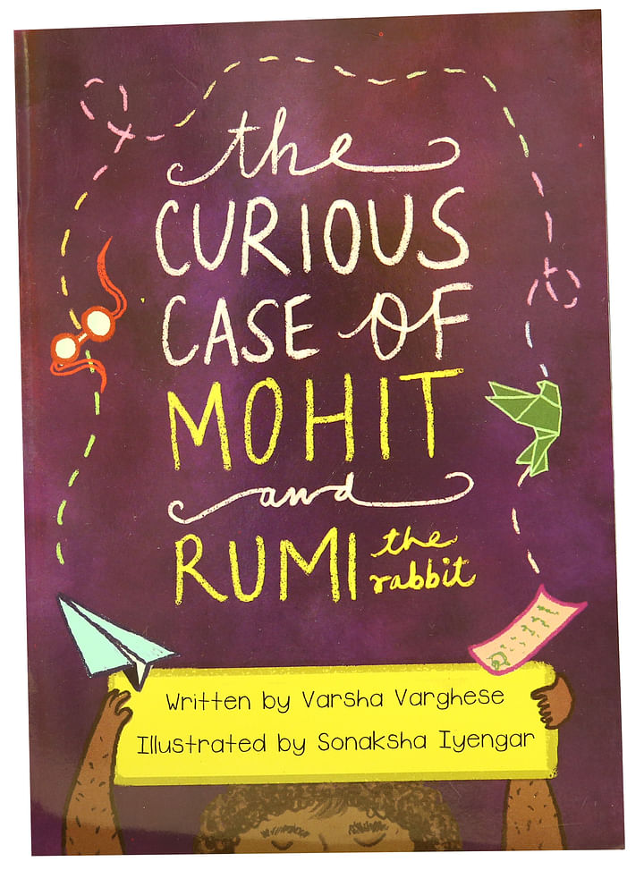

Book 6
TJ Powar has something to prove- Jesmeen Kaur Deo
Topic: Body Positivity
Age recommended: 16+ years
Publisher: Viking Books for Young Readers, June 2022
Why it’s important: Society has rules about what is considered beautiful. If you don't meet those rules, you might be treated badly, made fun of, or bullied for something you can't control. Based on the media we consume, this often means looking, thin, with a small waist, big lips, and perfect teeth.
But most of us don't look like that, and we never will. So, various messages from society inform us to try to change what we can. These messages push us to wear makeup, shave our body hair, and become someone we're not. Finding examples of alternative beauty standards can help encourage children not to conform to the normative beauty standards and find their own preferences.

Summary: TJ Powar, a popular high school debater, and her cousin Simran become internet meme sensations. The meme compares TJ's "expected" image as an Indian girl in a relationship to Simran's "real" identity as a Sikh girl who proudly embraces her body hair. This book through its engaging story tells us to accept ourselves the way we are.
In response, TJ takes a stand by ditching razors and canceling her waxing appointments. Her self-imposed debate resolution: "TJ Powar can be beautiful as her natural, hairy self." But as she works to prove her point, doubts creep in, especially when an annoying boy from a rival debate team challenges her.
As TJ's self-confidence crumbles, she realizes that winning this debate may cost more than just the hair between her eyebrows. The most challenging person to convince might just be herself.
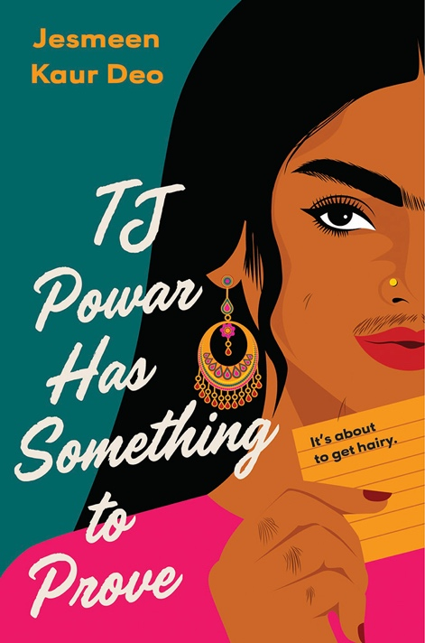

Book 7
How our Skin Sparkles – Aditi W. Singh
Topic: Body positivity
Age recommended: 5-8 years
Publisher: Raising World Children LLC, February 2020
Why it’s important: The author, through her book, does a great job of addressing important problems that children deal with when it comes to society’s rules. One of these problems is discrimination or bullying because of skin colour and race. It’s important to teach kids early that our skin colour is just one part of how we look, but it doesn’t define who we are as a person. Your skin colour should never make you feel like you can’t succeed and do well in life. Unfortunately this is not true only for Indian living overseas but also in India since the fairness of your skin is seen as an indicator of beauty

Summary: This story follows Aarav, a young boy who comes home one day wondering why he looks different from others. His mother uses a mix of science and their cultural background to help Aarav see that everyone has something special inside them. In the story, we get a peek into Indian culture, where traditions and values are important. It also shows how kids, like Aarav, have a special ability to see the real person inside, beyond how they look on the outside. This story teaches us about understanding, accepting, and appreciating the unique qualities that make each person special.

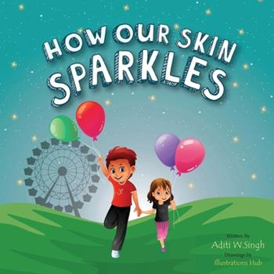

Book 8
Laxmi’s Mooch – Shelly Anand
Topic: Body positivity and acceptance
Age recommended: 6-8 years
Publisher: Kokila, March 2021
Why it’s important? Girls are often ridiculed for their facial and body hair and their self-esteem is constantly undermined due to that. A body positive book, Laxmi’s mooch, the Hindi term for moustache, illustrates how one can, not just accept, but enjoy one’s differences and feel confident.

Summary: Laxmi didn't really think about the tiny hairs above her upper lip. However, one day during recess when she was playing farm animals with her friends, they jokingly said her little hairs made her look like a cat. That's when she began to notice hair on different parts of her body, like her arms, legs, and even between her eyebrows.
With the guidance of her parents, Laxmi comes to understand that hair doesn't just grow on our heads; it can appear all over our bodies, no matter our gender.

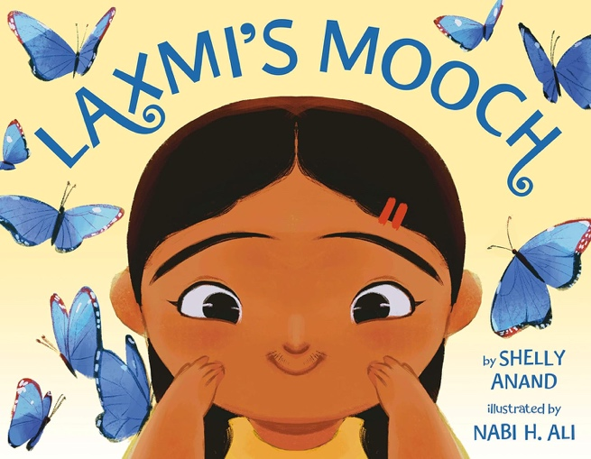

Book 9
Title: The Red Book- What you want to know about yourself – TARSHI
Topic: Body awareness
Age recommended: 10-14 years
Publisher: TARSHI, January 2016
Why it’s important: Instead of rushing to the internet for answers, here’s a book that provides vocabulary to children about their bodies, emergent feelings and desires, and how to identify abuse. In this way, it informs the readers about changes happening in young people’s bodies and how to accept these changes and not feel ashamed about them.

Summary: Growing up comes with a lot of changes and even more questions. But often there is no one to give you the correct answers. This book addresses changes in the teenage bodies, sex, sexuality and abuse in a very detailed and comprehensive manner.
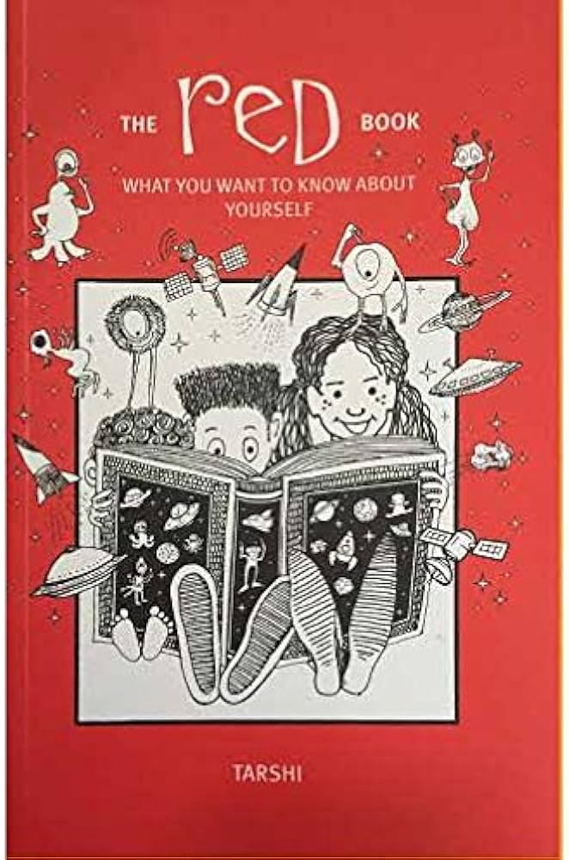

Book 10
Title: Beautifully Me – Nabela Noor
Topic: Body positivity
Age recommended: 5-8 years
Publisher: Simon & Schuster Books for Young Readers, September, 2021
Why it’s important: In today’s age, the idea of beauty is intertwined with the body weight. Slim is beautiful is a message splashed across all media. Unknowingly, children grow up hearing that fat is bad. The damage this does to children who do not fit certain body sizes is immensely shattering for their self-esteem. This beautifully illustrated children’s book advocates for self-love and shows the importance of healthy body image and rejects stereotyped beauty standards.

Summary: This story is about Zubi, a happy and spirited girl from Bangladesh, who is excited about her first day at school. But as the day goes on, she hears people talking about being overweight as something bad. This makes her question her own value because she is a chubby girl. She decides to go on a diet to try to look pretty.
With her parents guidance, Zubi realizes that she is beautiful just the way she is, and she learns to embrace and celebrate herself body. The book also encourages discussions about pronoun identity, the meaning of beauty, why people sometimes tease or say mean things about themselves and others. It encourages children to take pride in one's heritage, and being mindful of how our words can affect those around us.

